NAME: Group 20

REG NO: 2022t01342

COURSE UNIT: IA 2103

DATE: 13/06/2025

GROUP No: 20

**IA 2103 - Workshop Practice – Welding Techniques**

**Design for Manufacturability**

**Foldable Tri-Level Perforated Rack**

**Table of Contents**

1. Introduction .........................................................................................................1

2. Concept and Innovation ..................................................................................... 2

3. Design Description ............................................................................................. 3

4. Fabrication Process ............................................................................................ 4

5. Materials Used ................................................................................................... 5

6. Conclusion ......................................................................................................... 6

7. Cost Analysis ..................................................................................................... 7

8. Bill of Materials (BOM) .................................................................................... 8

9. Contribution of Group Members ....................................................................... 9

10. References & Conclusion ................................................................................13

**1. Introduction**

This document presents the design and manufacturing plan for a Foldable Tri-Level Perforated Rack. The product is engineered to provide a durable and space-efficient solution for drying or storing items, particularly in industrial and mechanical environments. The design integrates basic welding techniques and structural optimization, making it suitable for low-cost fabrication in workshop conditions.

**2. Concept and Innovation**

The core concept of the Foldable Tri-Level Perforated Rack is to allow users to access multiple levels of storage or drying surface with a foldable steel frame. Each level uses perforated sheet metal to provide ventilation and weight reduction. The rack's frame is built using standard steel square tubing, while the foldable mechanism allows the unit to be compact when not in use.

**3. Design Description**

The rack is designed with three perforated shelves supported by a triangular welded steel frame. The use of punched metal sheets ensures airflow and reduces material weight. The side frames are welded to provide structural rigidity, and the entire unit is designed for wall-mounting or floor standing based on user need.

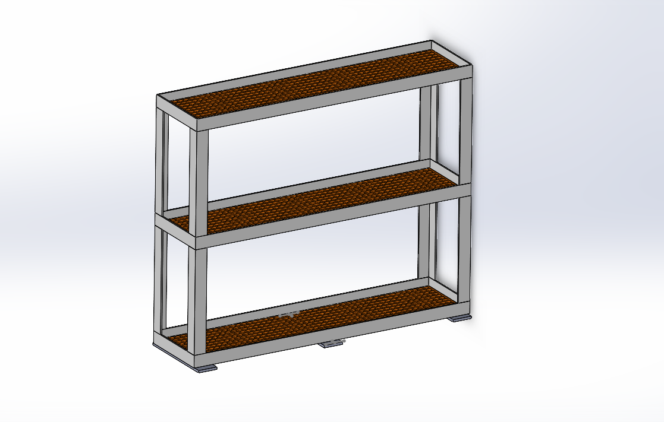

*Figure 1 - Full Assembly - Front Isometric View*

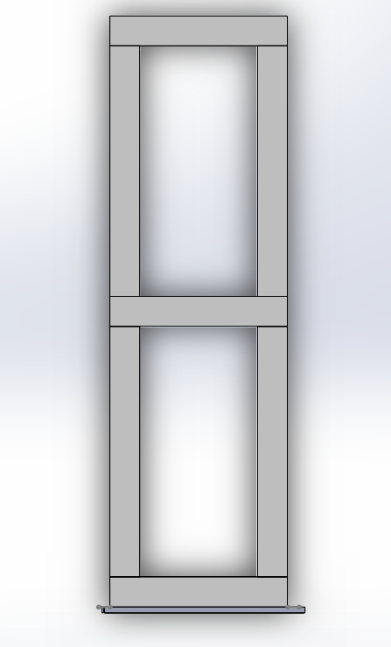

*Figure 2 - Full Assembly - Rear Isometric View*

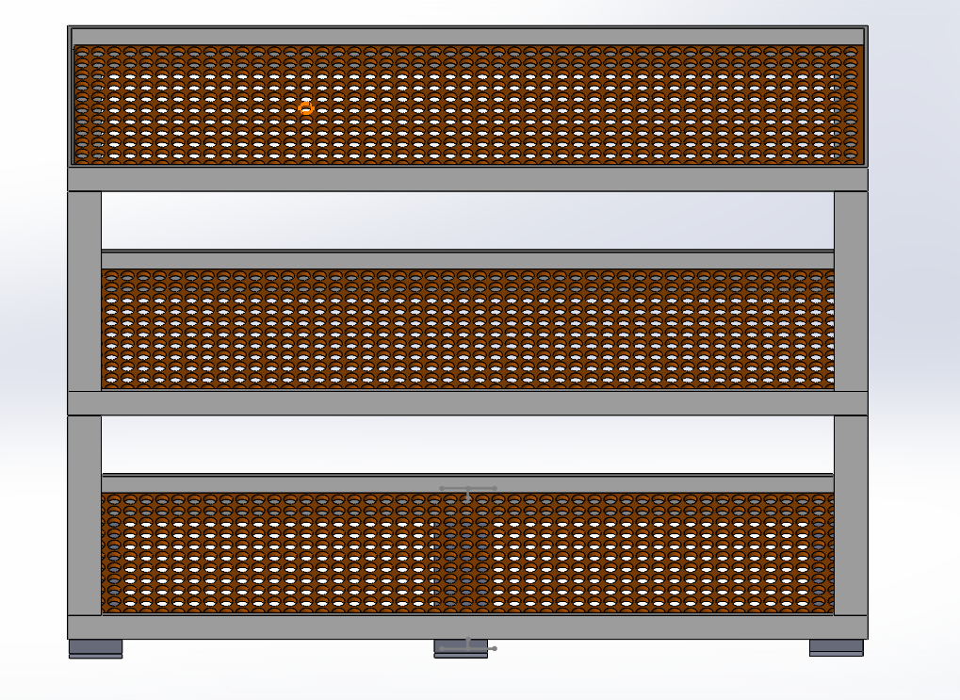

*Figure 3 - Front View of Rack*

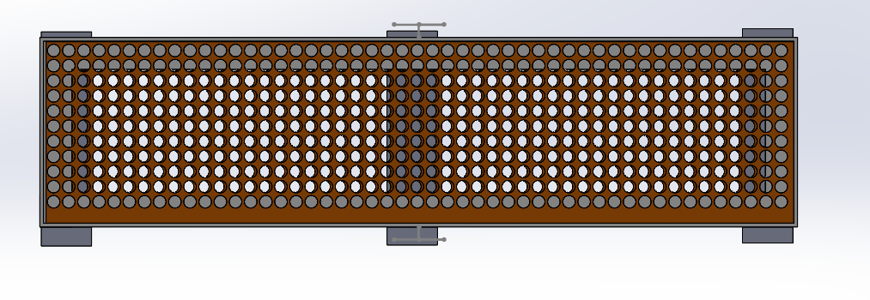

*Figure 4 - Top View of Rack*

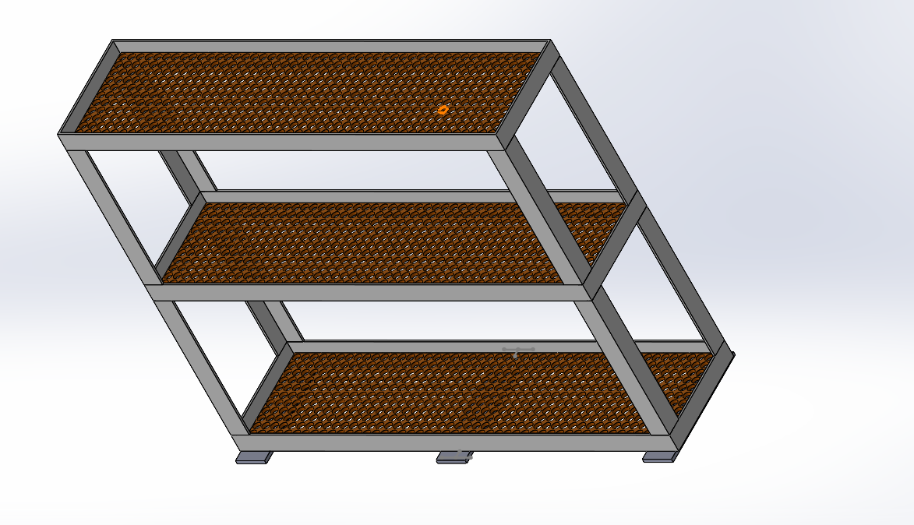

*Figure 5 - Folded Position - Side Isometric*



*Figure 6 - Folded View - Side Frame*

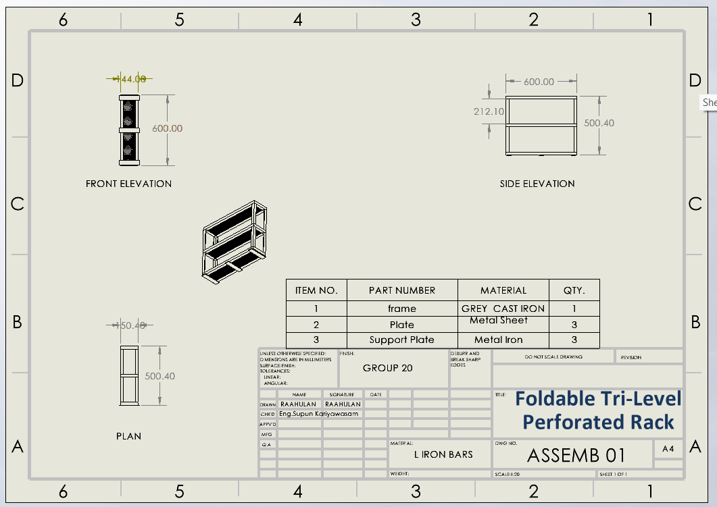

*Figure 7 - Engineering Drawing Sheet*



*Figure 8 - SolidWorks Isometric Model*

**4. Fabrication Process**

• Step 1: Material Preparation  
All required materials, including square steel tubes (20x20 mm) and perforated sheet metal, are selected based on the Bill of Materials.  
Tubes are measured and marked using a steel scale and scriber.  
A metal chop saw is used to cut tubes precisely.  
  
• Step 2: Sheet Cutting and Finishing  
Sheets are cut using guillotine shear.  
Edges are deburred using a bench grinder for safe handling.  
  
• Step 3: Drilling and Hinge Placement  
Mounting holes are drilled using a pedestal drill.  
Clamps are used to ensure proper alignment.  
  
• Step 4: Welding and Frame Assembly  
Tack welds ensure alignment before full arc welds are done.  
Special care is taken to maintain proper angles.  
  
• Step 5: Hinge and Stand Integration  
Hinges are bolted for foldability.  
Supports are tested for motion and locking.  
  
• Step 6: Surface Treatment  
Frame cleaned with degreasing solution.  
Coated with primer and enamel paint for corrosion resistance.  
  
• Step 7: Final Assembly and Testing  
Complete system is assembled and tested for load.  
Folding and locking mechanisms are checked thoroughly.

**5. Materials Used**

- Square steel tubing (20x20 mm)  
- Perforated sheet metal  
- Welding electrodes  
- Hinges and fasteners  
- Anti-rust primer and paint

**6. Cost Analysis (Estimated - Sri Lankan Market)**

|  |  |  |
| --- | --- | --- |
| Component | Description | Estimated Cost (LKR) |
| Square Steel Tubes (20x20 mm) | 6 meters @ ~LKR 450/meter | 2,700 |
| Perforated Sheet Metal | 2 sheets @ ~LKR 1,000/sheet (1.5ft x 3ft, 1mm thick) | 2,000 |
| Welding Electrodes | 10 rods @ ~LKR 30/rod | 300 |
| Hinges and Fasteners | Hinges, bolts, washers, nuts | 800 |
| Grinding & Cutting Discs | 1 disc each for cutting & smoothing | 500 |
| Surface Preparation & Paint | Primer + Enamel paint | 1,500 |
| Electricity + Labor Cost | Estimated 3 hours @ LKR 250/hour | 750 |
| Total Estimated Cost |  | 8,550 |

**7. Bill of Materials (BOM)**

|  |  |  |  |
| --- | --- | --- | --- |
| Item | Material / Component | Dimensions | Quantity |
| 1 | Square Steel Tube | 20mm x 20mm x 2mm, 1000mm length | 6 pcs |
| 2 | Perforated Sheet Metal | 3ft x 1.5ft x 1mm | 2 sheets |
| 3 | Mild Steel Hinges | 2" x 1.5" | 3 pcs |
| 4 | Hex Bolts + Nuts + Washers | M6 x 20mm | 12 sets |
| 5 | Welding Electrodes | E6013, 2.5mm | 10 rods |
| 6 | Paint & Primer | Standard Enamel & Rust Primer | As required |
| 7 | Grinding Disc | 4-inch | 1 pc |
| 8 | Cutting Disc | 4-inch | 1 pc |

**8. Cost Analysis and Pricing**

Component-wise cost estimation:

|  |  |  |
| --- | --- | --- |
| Component | Description | Estimated Cost (LKR) |
| Square Steel Tubes | 6m @ 450 | 2,700 |
| Perforated Sheet Metal | 2 sheets @ 1000 | 2,000 |
| Welding Electrodes | 10 rods @ 30 | 300 |
| Hinges/Fasteners | Bolts, nuts, hinges | 800 |
| Grinding/Cutting Discs | 1 each | 500 |
| Surface Paint | Primer + Enamel | 1,500 |
| Labor + Electricity | 3 hrs @ 250/hr | 750 |
| Total |  | 8,550 |

Pricing Strategy:  
• Wholesale Price: LKR 10,000  
• Retail Price: LKR 11,500

**9. Contribution of Group Members**

|  |  |  |
| --- | --- | --- |
| **Index Number** | **Name** | **Contribution (%)** |
| 2022t01340 | THARUSHA RAJAPAKSHA | 25% |
| 2022t01341 | S.PUVANITHAN | 25% |
| 2022t01342 | M.RAAHULAN | 25% |
| 2022t01343 | THARINDU | 25% |

**10. References**

* Kalpakjian, S., & Schmid, S. R. (2014). Manufacturing Engineering and Technology.
* Groover, M. P. (2015). Fundamentals of Modern Manufacturing.
* SolidWorks User Manual - Dassault Systèmes
* <https://www.wcwelding.com/welding-techniques.html>
* <https://bnshardware.lk/>
* Using SOLIDWORKS_2020_Premium

**11. Conclusion**

The **Foldable Tri-Level Perforated Rack** is a practical product designed for ease of manufacturing, cost-efficiency, and structural reliability. Its design supports scalability for commercial applications and meets the coursework requirement for welded assembly in a real-world context.